
B
HY/CS/1220/B 19/11/2020
HALF YEARLY EXAMINATION (2020-21)
Subject: COMPUTER SCIENCE  Grade: XII |  | Max. Marks: 70  Time: 3 Hrs
General Instructions:
1. This question paper contains two parts A and B. Each part is compulsory.
2. Both Part A and Part B have choices.
3. Part-A has 2 sections:
a. Section – I is short answer questions, to be answered in one word or one line.
b. Section – II has two case studies questions. Each case study has 4 case-based subparts. An examinee is to attempt any 4 out of the 5 subparts.
4. Part - B is Descriptive Paper.
5. Part- B has three sections
a. Section-I is short answer questions of 2 marks each in which two question have internal options.
b. Section-II is long answer questions of 3 marks each in which two questions have internal options.
c. Section-III is very long answer questions of 5 marks each in which one question has internal option.
6. All programming questions are to be answered using Python Language only.
Q | Part- A
 | SECTION-I  Answer the following questions. Attempt any 15 questions from Section-1 |  | 15
1 | What is the output of the following?  print("xyyzxyzxzxyy".count('xyy', 2, 11)) |  | 1
2 | What is the output when following code is executed?  >>>str1="helloworld"  >>>str1[::-1] |  | 1
3 | State the size of the following constants: -  - “it\’s” ii) “Rohan\n” |  | 1
4 | State the output of the following Python statements: -  - print(10=="10")  - print("Bag">"BAg") |  | 1
5 | Name the Python Library modules which need to be imported to invoke the  following functions:  - sin()  - randint () |  | 1
6 | Which of The Following Statements Given Below Is/Are True?  A. Tuples have structure, lists have an order.  B. Tuples are homogeneous, lists are heterogeneous.  C. Tuples are immutable, lists are mutable.  D. All of them. |  | 1
7 | Write one similarity and one difference between list and dictionaries. |  | 1
8 | Which of the following are invalid identifiers?  abc_d, break, 1rak, doc14, a2bc5, _punc, ray.dat |  | 1
9 | Give the output.  print(“2”+”3”)  print(“2”*3) |  | 1
10 | What is IDLE? Is it Compiler based or Interpreter based? |  | 1
11 | Which is the not advantage of DBMS?  - Databases reduce the data redundancy.  - Database can control data inconsistency.  - Database can enforce standard  - Relational Integrity is maintained. |  | 1
12 | In SQL which command is used to give only one set of duplicated values?  - SELECT UNIQUE  - SELECT DIFFERENT  - SELECT DISTINCT  - ALL OF THE ABOVE |  | 1
13 | Differentiate between Candidate Key and Alternate Key. |  | 1
14 | Differentiate between UNIQUE and Primary Key Constraint in SQL. |  | 1
15 | Write a SQL query to insert record only in Selected fields (ENO, ENAME, GENDER, SAL, BONUS) in Employee Table.  The values to be inserted are  (2,’RATUL’,’M’,5500,125) |  | 1
16 | Give full form of following:  - IPR  - SMTP |  | 1
17 | . Reena says that the following numbers indicate an address:  00: 22: 6B: FF: 24: 12  What is the above address called? To which object/device is it assigned? |  | 1
18 | What out of following will you use to have an audio-visual chat with an expert sitting in a far-away place to fix up a technical issue? Also mention the reason.  - Email (ii) VoIP (iii) FTP |  | 1
19 | Arrange the following communication channels in ascending order of their data transmission rates.  Ethernet cable, Optical Fiber, Telephone cable, Co-axial cable. |  | 1
20 | International Tour and Travels company has set up its new branch office in Jaipur where different buildings are spanned over in the radius of 900 meter in Jaipur. Name the network formed in the following situations:  (i) The branch office is connected with the regional office in New Delhi.  (ii) All the buildings of branch office are connected to each other. |  | 1
21 | Give the full form of CSV and where it is used? |  | 1
 | SECTION-II  Both the Case study-based questions are compulsory. Attempt any 4 sub parts from each question. Each question carries 1 mark |  | 8
22 | A Sports Club is considering maintaining their inventory using SQL to store the data. As a database administer, Shiv has decided that:  • Name of the database – Club_Database  • Name of the table - CLUB  • The attributes of CLUB are as follows:  MCode - numeric  MName– character of size 20  Gender - character of size 20.  Age-numeric  Fees – numeric  Type - character of size 20.
  Mcode | Mname | Gender | Age | Fees | Type
  1 | Ashish | Male | 35 | 7000 | Monthly
  2 | Anannya | Female | 25 | 8000 | Monthly
  3 | Gitika | Female | 42 | 24000 | Yearly
  4 | Harshika | Female | 27 | 12000 | Quarterly
  5 | Tarun | Male | 54 | 6000 | Monthly
  6 | Krish | Male | 43 | 4500 | Monthly
 | - Shiv wants to see other tables existing in the same database. Give command to see the other tables in Club_Database.  - Shiv wants to delete the Age Column from the table. Write SQL Query for same.  - Now Shiv wants to display the structure of the table CLUB, i.e, name of the attributes and their respective data types that he has used in the table. Write the query to display the same.  - Write the degree and Cardinality of the table. (Assume that Age field is there in the table.)  - Shiv wants to add new column named Address of type varchar(20). Give command to add new column. |  | 1  1  1  1  1  1
23 | Raveesh Kumar of class 12 is writing a program to create a CSV file “details.csv” which will contain username and roll for some entries. He has written the following code. As a programmer, help him to successfully execute the given task.  import _____________ # Line 1  def addCsvFile(UserName,Roll): # to write / add data into the CSV file  f=open(' details.csv','________') # Line 2  newFileWriter = csv.writer(f)  newFileWriter.writerow([UserName,Roll])  f.close()  #csv file reading code  def readCsvFile(): # to read data from CSV file  with open(' details.csv','r') as newFile:  newFileReader = csv._________(newFile) # Line 3  for row in newFileReader:  print (row[0],row[1])  newFile.______________ # Line 4  addCsvFile(“Arjeet”,1)  addCsvFile(“Arun”,2)  addCsvFile(“Freddy”,3)  readCsvFile() #Line 5
 | (a) Name the module he should import in Line 1. |  | 1
 | (b) In which mode, Raveesh should open the file to add data into the file |  | 1
 | (c) Fill in the blank in Line 3 to read the data from a csv file. |  | 1
 | (d) Fill in the blank in Line 4 to close the file. |  | 1
 | (e) Write the output he will obtain while executing Line 5. |  | 1
 | PART B
 | SECTION-I |  | 20
24 | Find the errors in the below code and underline each correction.  x = int(“Enter value for x:”)  for y in range [0,11]  if x = y  print x + y  else  print x – y |  | 2
25 | Give the output of the following Python statements.  L=list("data")  X=""  count = 1  for i in L:  if i in ["a","e","i","o","u"]:  X=X+i.swapcase()  else:  if (count%2) != 0:  X=X+str(len(L[:count]))  else:  X=X+i  count=count+1  print(X)  print(count) |  | 2
26 | WAPS to find the length of shortest string in tuple of strings.  Example :  t=("Sun", "revolves", "around", "earth")  Smallest string : Sun  Length of smallest string : 3 |  | 2
27 |  |  | 2
  Observe the following program and answer the question that follows:
  import random
  x=random.random()
  y=random.randint(0,4)
  print(x," : ",y)
  Choose the possible outputs
  a)1:3
  b)0:4
  c)0.5:3
  d)1:4
28 | Differentiate between Trademark and Copyright.  OR  Differentiate between Hacker and Cracker. |  | 2
29 | Give the full forms of the following:  - TDMA  - BDMA  - CDMA  - FDMA |  | 2
30 | Differentiate between EQUI JOIN and NATURAL JOIN giving examples of each. |  | 2
31 | Differentiate between Selection and Projection Operation in SQL, giving examples for both. |  | 2
32 | Consider the tables given below.  Relation: Stud  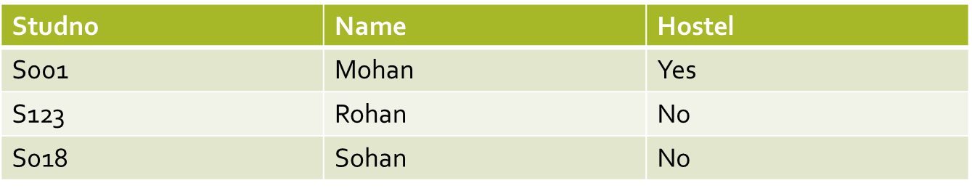  Relation: Teacher  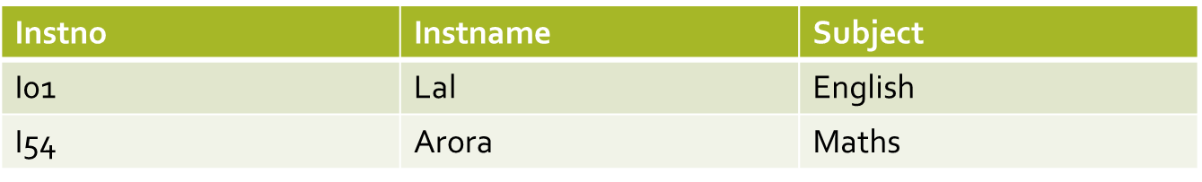  Give the output of the following command  SELECT * from STUD, TEACHER; |  | 2
33 | State two advantages and two disadvantages of STAR topology. |  | 2
 | SECTION – II |  | 12
34 | Consider the following List (scode, name, salary)of Staff, write a method in python to search and display the content in a CSV file “staff.csv”, by decreasing 10% of salary(float) to all the staff.  OR  Considering a List containing FACTORY with (FID, FNAME, PRODUCTION) write a function in Python to search and display the content in a CSV file “FACTORY.CSV”, where FID is matching with the value ‘119’. |  | 3
35 | 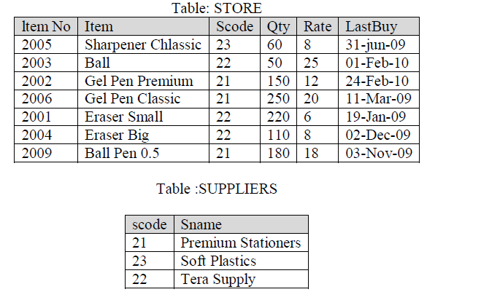  Given the above SQL tables, Write the output of Queries given below.  (i) SELECT Item, SUM (Qty) FROM Store GROUP BY Scode;  (ii) SELECT Rate*Qty FROM Store WHERE ItemNO = 2004;  (iii)SELECT Item, Sname FROM Store S, Suppliers P WHERE S.Scode = P.Scode AND Item_No = 2006 ; |  | 3
36 | Create a dictionary Product containing product name and price.  - Add products to dictionary till user wants.  - Ask for a product and change its price.  - Delete a user entered product. |  | 3
37 | Write a function in Python PUSH(Item), where Item is a list of numbers. From this list push all numbers divisible by 2 into a stack implemented by using a list. Display the stack if it has at least one element, otherwise display appropriate error message.  OR  Write a function in Python POP(Item), where Item is a stack implemented by a list of numbers. The function returns the value deleted from the stack. |  | 3
 | SECTION III |  | 15
38 | Quick learn university is setting up its academic blocks at Prayag Nagar and planning to set up a network. The university has 3 academic blocks and one human resource center shown in the diagram below :-  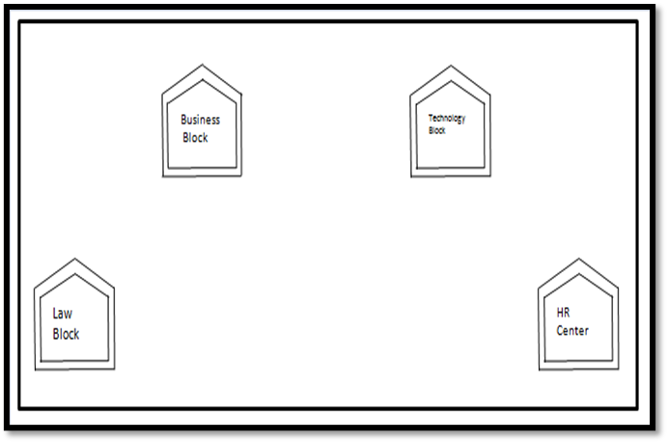  Center to center distances between various block/center is as follows:  Number of computers in each of block /center is as follows  (i) Suggest a cable layout of connections between the blocks.  (ii) Suggest the most suitable place (i.e. block/center) to install the server for this university. Also, provide a suitable reason for your suggestion.  (iii) which device you will suggest to be placed /installed in each of these blocks/center To efficiently connect all the computers with in these block/center  (iv)The university is planning to connect its admission office in the closest big city, which is more than 250 km from university, which type of network out of LAN, MAN, WAN will be formed? Justify your answer.  (v) Radhika wants to upload and download files from / to a remote internet server, write the name of the relevant communication protocol, which will let her do the same. |  | 5
  Law Block to Business Block | 40 m
  Law Block to Technology Block | 80 m
  Law Block to HR Center | 105 m
  Business Block to Technology Block | 30 m
  Business Block to HR center | 35 m
  Technology Block to HR Center | 15 m
  Law Block | 15
  Technology Block | 40
  HR Center | 115
  Business Block | 25
39 | Consider the following tables and write the SQL Queries for the questions that follow  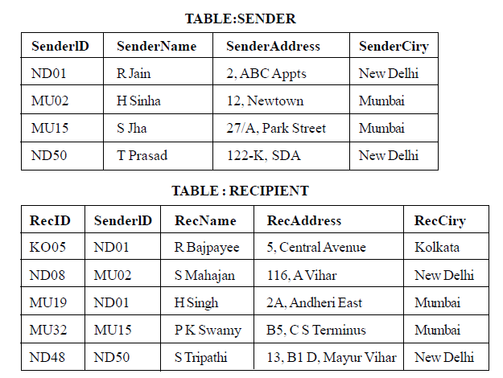  - To display the sender name, recipient name and sender city for all deliveries for Mumbai.  - To display the count of deliveries from each city.  - To display the sender name whose sender address begins with 12.  - To display Recipient details in ascending order of RecName  - To display number of Recipients from each city. |  | 5
40 | A binary file “Salary.dat” has structure [Code, Name, Sal].  - Write a user defined function to add records to the file  - Write a user defined function to increase everyone’s salary by 10000  OR  A binary file “Book.dat” has structure [BookNo, Book_Name, Author, Price].  i. Write a user defined function CreateFile() to input data for a record and add to Book.dat .  ii. Write a function CountRec(Author) in Python which accepts the Author name as parameter and count and return number of books by the given Author are stored in the binary file “Book.dat” |  | 5
***

